**BOOTSTRAP NOTES**

2. Add a Bootstrap card to display each movie that is showing in the Showtimes section of the webpage. This will be accomplished through completing the following steps:

a. Insert a Bootstrap code snippet under the jumbotron section of your code.

TIPS:

* On the Bootstrap documentation page, use the menu guide at the side of the page to locate the card component.
* Read Bootstrap’s documentation on cards.
* Copy the code snippet for the card layout of your choosing and insert it into your code.
* Edit the Bootstrap code as needed.



**BOOTSTRAP PROJECT**

f. Implement info pill badges in your website.

Do this by:

I. Researching badge components on the BootStrap website.

II. Researching pill badges on the Bootstrap website.

III. Researching colors on the Bootstrap website and learning what the “info” color is.

IV. Copying the code snippet for the info pill badge on the Bootstrap website.

V. In your code, navigate to the <p> elements and remove all nested <small> tags.

VI. In their place, paste five copies of the info pill badge code snippets.

VII. Between the span tags (nested within the <div class=”card”> sections) write the following showtimes for each movie:

* 12:00 p.m.
* 1:30 p.m.
* 3:00 p.m.
* 5:30 p.m.
* 7:00 p.m.
* 9:30 p.m.

TIPS:

[**Badge Component**](https://getbootstrap.com/docs/4.3/components/badge/)

[**Pill Badges**](https://getbootstrap.com/docs/4.3/components/badge/#pill-badges)

[**CSS Colors**](https://getbootstrap.com/docs/4.3/utilities/colors/)

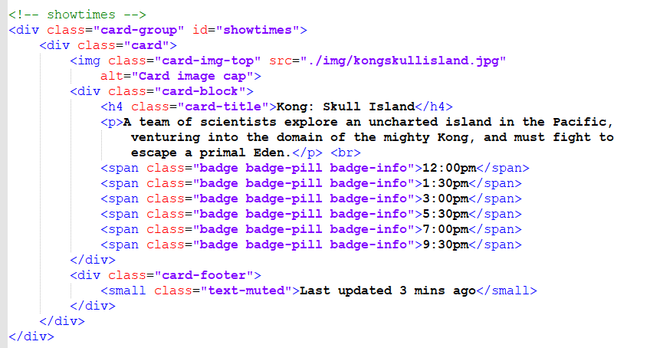

(Repeat for other movies)

**ASSIGNMENT**

Read through all the code contained within the Bootstrap starter template and ensure you comprehend what every line does. Clear up anything you don’t understand through researching online for definitions and explanations.

Here is the Bootstrap starter template:

[**https://getbootstrap.com/docs/4.3/getting-started/introduction/#starter-template**](https://getbootstrap.com/docs/4.3/getting-started/introduction/#starter-template)

**BOOTSTRAP**

As mentioned earlier, Bootstrap utilizes a grid system. For example, this code:

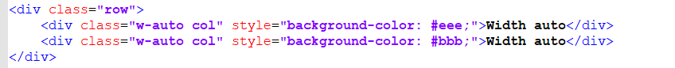

Would have the following output:

https://techacademystorage.blob.core.windows.net/htmlandcss/grid2.PNG